PWA Tutorial Video 7 Service Worker Lifecycle events

<https://www.youtube.com/watch?v=NhQfvZoRb2Q>

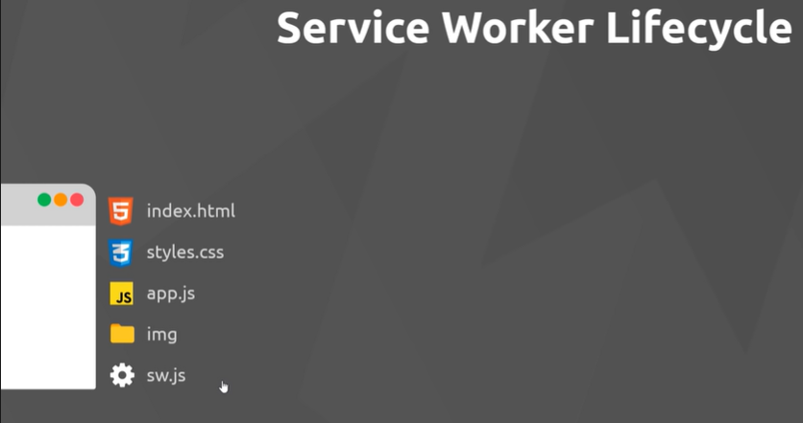

SW in root for global control

App.js registers the service worker - put it on that thread.

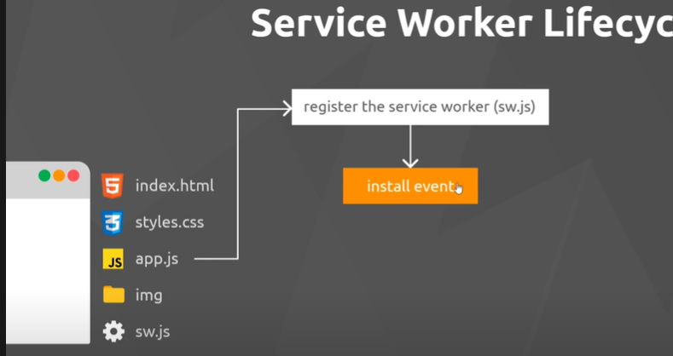

Asset cashing for use off line,

the install event just fires when service worker is installed

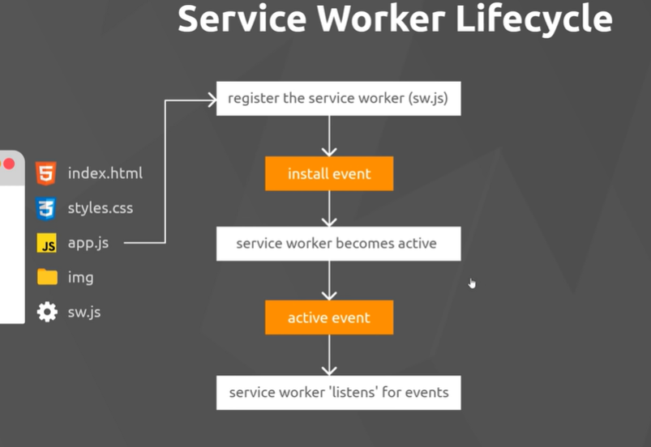

Once the service worker is active (installed) it can access all the files and pages on the site

Listens for events and can intercept them if needed

With page refresh the SW is still registered, so it only re installs if the code within it has changed since the last time it was installed.

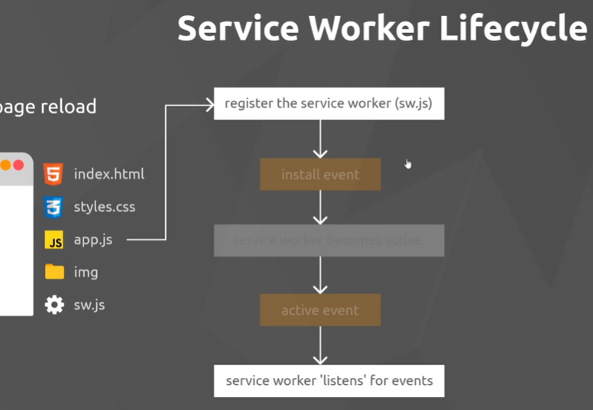

With new service worker in waits until refresh before becoming active to avoid breakage

